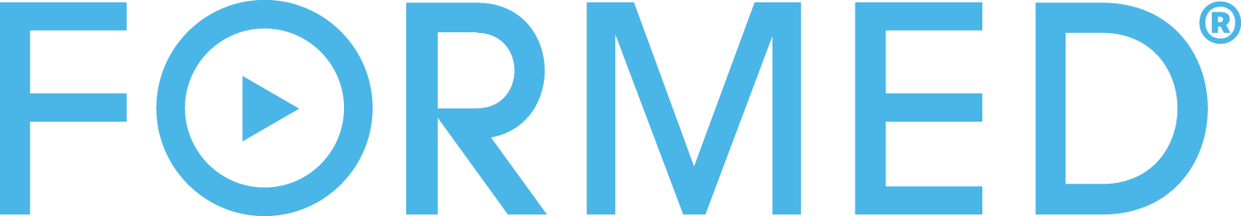

Lectio Mark Parish-Wide Study
Pulpit Pitch: 2-3 minutes

Before the final blessing, celebrant invites the person who is going to speak about FORMED to come up to the ambo, OR Father makes the announcement himself.
Good Morning/Evening!
To begin, I want to personally thank Fr. _____ for purchasing the gift of FORMED for our whole parish! (pause/smile) FORMED is an innovative online platform and app with hundreds of inspiring movies, video series, audio talks, and ebooks from the Church's most compelling speakers and authors. We will soon start to go through one of the video series on FORMED as a whole parish.
By a show of hands:
- How many of you would like to read the Bible, but find it difficult to understand or stay engaged?
- How many of you would like the opportunity to go through just one book of the Bible, one of the Gospels, with the guidance of a popular Scripture scholar and guide books to help you pray with Scripture?
That’s what we’re inviting you to do as a whole parish family in this video series on FORMED called Lectio Mark. The Latin word lectio means “reading,” and often refers to a careful and prayerful reading of Scripture. In Lectio Mark, Dr. Tim Gray will use the prayer tradition of lectio divina to help us discover the Gospel of Mark in a new way. Lectio Mark will move your heart and give you plenty to discuss as a family or as a group of friends over the weeks.
You can watch the series at home or with a group every week on FORMED!

[Flocknote Option]
How many of you have not yet signed up for our parish's Flocknote? Flocknote is a service that allows a pastor to message his flock! Pull out your phones and text this message to this number [Ex. Text HOLYCROSS to 84576] and you will be added to our Parish Flocknote.
Now to get you setup on FORMED quickly, we will now send you a text message that has a link that will give you FREE access to FORMED. Click that link, fill out the registration information, and you will be ready to access all the inspiring content on FORMED!
FORMED is also an app for smart TVs, and Apple and Android mobile devices! Go to the App Store or the Google Play store to download the app and have great Catholic content at your fingertips. Please see our tech team volunteers to help you get fully setup.
OR
[Reverse Collection Option]
So, as I finish speaking the ushers will pass the collection basket again. Instead of putting in a donation, please take out of the basket a business card that tells you how to create your free FORMED account and start watching Lectio Mark, as well as all the other amazing content.. In fact, take a few if you would like and share them with your neighbors!
OR
[Bulletin Insert Option]
In the parish bulletin (show insert) is a flyer with information on how to register for free access to FORMED, please take one as you leave.

[Close with this message]
Thank you for your time! I will be in the gathering space at the end of Mass to answer any questions and help you sign up.

FOLLOW UP
The next week, Father should make an announcement at the end of each service and ask:
"Last week you received a [business card/Flocknote text message] with our parish's FORMED information (hold the card up). Did you register yet? If you didn’t, please do so this week, so you can join us in watching the Lectio Mark series together as a parish. (Give details of how, where, and when)
If you did register, please pass on that [card/information] to a family member, neighbor, or friend so that they can register for FORMED as well."

