Bulletin Blurb and Sample Parish Email To Send To Parishioners

Parish leaders, feel free to use this in your bulletin, and/or copy and paste this into an email and send it to your parishioners.

Subject Line/Header:
Sign up for The Road to Bethlehem this Advent on FORMED.org

Body of the Email/verbiage for bulletin:

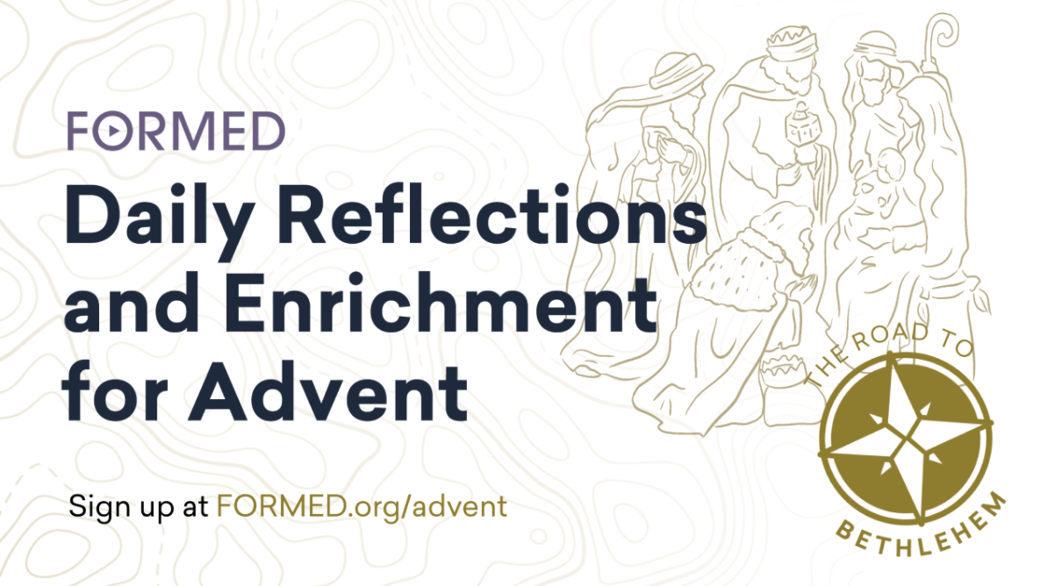
This Advent join us for a journey on The Road to Bethlehem, an opt-in digital discipleship program designed to guide you through this important season of preparation.

The Road to Bethlehem includes:

- daily Advent reflections by Dr. Tim Gray;
- weekly videos, audio talks, and book excerpts on FORMED related to the weekly theme;
- email reminders every morning;
- Brother Francis Advent reflections for kids; and
- a weekly action item to help you put the Advent message into practice.

Advent starts November 29. Sign up today for free!
FORMED.org/Advent

Not yet on FORMED?
- Visit http://signup.formed.org/.
- Enter our parish’s zip code or name.
- Enter your name and email.

11-20-20/DB

